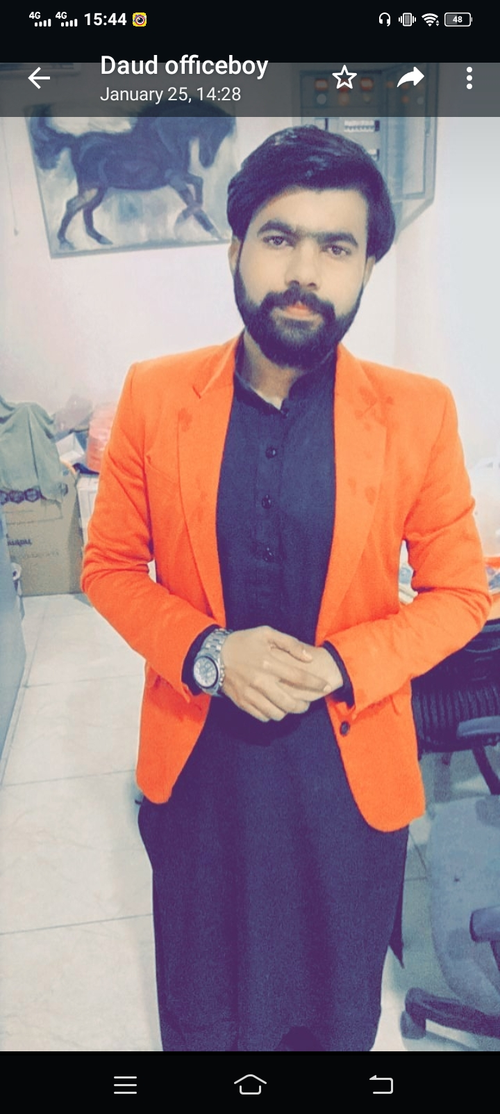

Muhammad Shahzaib

+9202-5490839

+9214-2464360

Shahzaibmahar27@gmail.com

### Highlights

* CV Sourcing
* Recruitment Process Outsourcing
* Word/Excel/PowerPoint
* Social Media Handler
* Premium Pro
* Adobe Photoshop
* Adobe Illustrator
* Figma
* Canva
* HTML
* CSS
* Bootstrap
* Lead Generation Expert

### Education

MCS: Master in Computer Science - 2020

Islamia Univeristy Bahawalpur,PK

### Certificates

* IOSH Safety
* OSHA Construction
* OSHA General
* Fire Safety
* First Aid Etc…
* Computer Courses

### Experience

05/2021 to Continue

**CV Resource /Administration/ Lead-Generation Expert**

**TGI Search**, Bahawalpur

* Daily Basis create Boolean String or Finds different clients CVS
* Using UK Job Boards, LinkedIn to finds CVS
* Creates Leads in Excel Sheet
* Now Find First-Name, Last-Named, Company URL, LinkedIn, Emails, Company Revenue, Etc.

**Social Media Executive (Internship)** 07/2023 to Continue

**Azaan Developer,** Bahawalpur

* Social Media Post Design
* Organic way to run daily Basis post Facebook, Instagram,

**Graphics Designer/Web Designing** 05/2022 to 3/2023

**SPOTGAME,** Bahawalpur

* Daily basis Social Media Post, Boucher-Design
* Flyer-Designs, Standee-Designs, Logo Designs

**CV Sourcing, Administration, RPO (**Recruitment Process Outsourcing) **Services**, equipped with extensive experience With Different **UK** Clients.

**Graphics Designer/Social Media Executive**

(Adobe Photoshop, Adobe Illustrator, Canva Expert (video Editing).