**CV Sourcing, RPO (**Recruitment Process Outsourcing) **Services**, equipped with extensive experience With Different **UK** Clients.

**Graphics Designer**

(Adobe Photoshop, Adobe Illustrator, Canva Expert).

**Front-End Developer**

(HTML, CSS, Bootstrap, Landing Pages Designs, Theme, Elementor plugin)

**()**

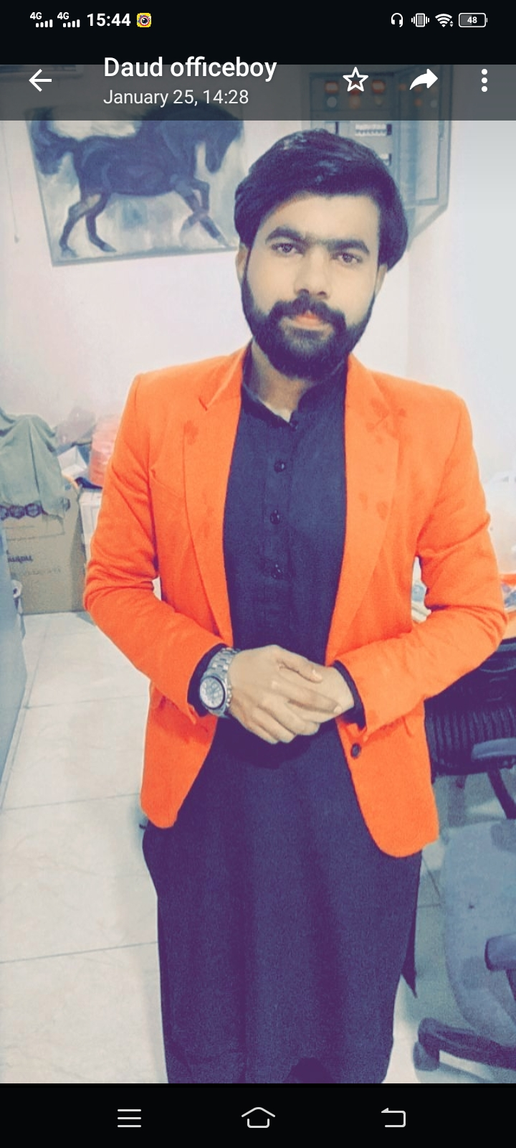

Muhammad Shahzaib

+9202-5490839

+9214-2464360

Shahzaibmahar27@gmail.com

### Highlights

* CV Sourcing
* Recruitment Process Outsourcing
* Boolean string
* Boolean String Generate
* Adobe Photoshop
* Adobe Illustrator
* Figma
* Canva
* HTML
* CSS
* Bootstrap
* Lead Generation Expert

### Education

MCS: Master in Computer Science - 2020

Islamia Univeristy Bahawalpur,PK

### Certificates

* IOSH Safety
* OSHA Construction
* OSHA General
* Fire Safety
* First Aid Etc…
* Computer Courses

### Experience

05/2021 to Continue

**CV Resource /RPO/ Lead Generation Expert**

**TGI Search**, Bahawalpur

* Daily Basis create Boolean String or Finds different clients CVS
* Using UK Job Boards, LinkedIn to finds CVS
* Creates Leads in Excel Sheet
* Now Find First-Name, Last-Named, Company URL, LinkedIn, Emails, Company Revenue, Etc.

**Call Center Representative (Medical Billing)** 03/2023 to 09/2023

**EHS,** Bahawalpur

* 6Month Experience

**Graphics Designer** 05/2022 to 12/2022

**SPOTGAME,** Bahawalpur

* Daily basis Social Media Post, Boucher-Design
* Flyer-Designs, Standee-Designs, Logo Designs

04/2023 to Continue

**Ui/UX designer or Front End Developer**

**DigitalFello,** Bahawalpur

* HTML, CSS, Bootstrap,
* Landing Pages Designs