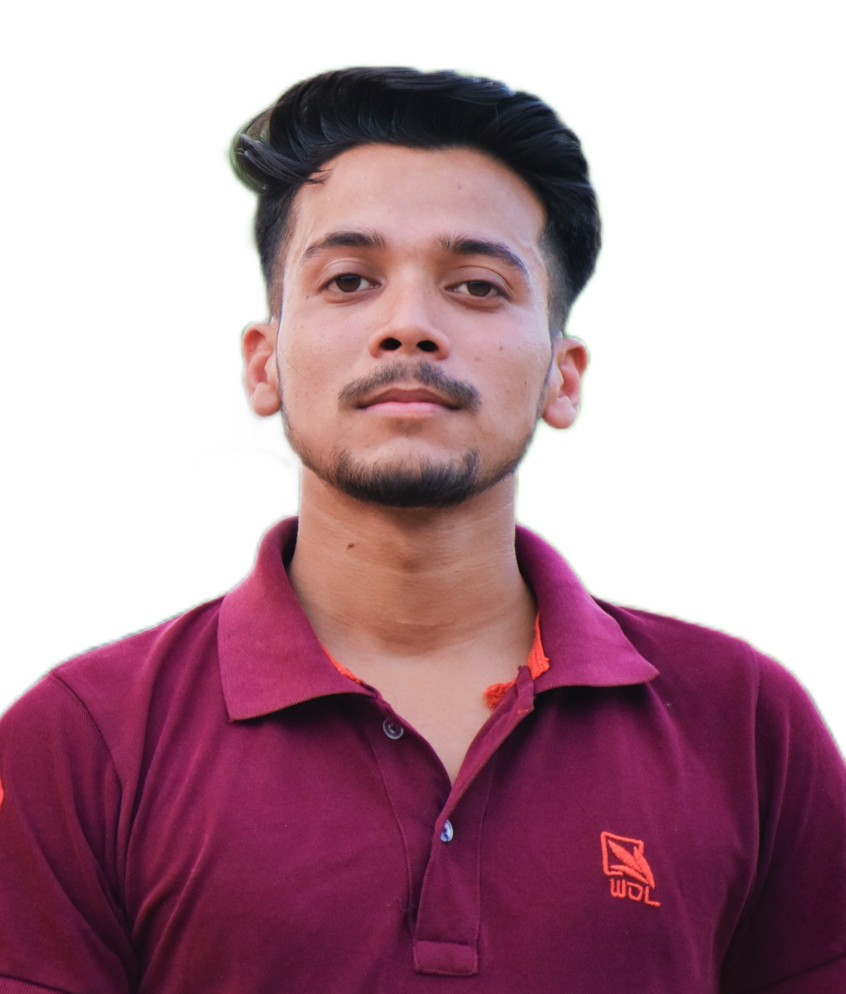 |  | pushpendrasingh chauhan
Profile  “ As a fresher, I need a platform to prove my ability. If I will be a part of your company, I'll put my effort and strength to uplift your company. None is born with experience, and if you hire me, I will get professional experience through your company."  Contact  PHONE:  9120364097  LINKED IN  https://www.linkedin.com/in/pushpendra-singh-chauhan-b476101a3  LANGUAGE  Hindi  English  EMAIL:  Pushpendrasingh2017stp@gmail.com  Hobbies  Photography  Travelling  Gardening  Singing |  | EDUCATION  HIGH SCHOOL  Bhartiya inter College Pihani Hardoi (2016)  82%  INTERMEDIATE  Anandi Devi Saraswati Vidhya Mandir inter College Sitapur (2018)  (68.8%)  GRADUATION  B.N. College of Engineering and Technology ( lucknow ) (2022)  8TH SEM (Appearing)  (70%)  PROJECTS COORDINATION AND MANAGE  [ Pharmacy Management System ] (MINI PROJECT)  5TH Semester  [ Railway Reservation System ]  8th semester  [ INTERNSHIP ]  6 MONTH WEB DESIGNING (LUCKNOW)  HTML CSS JAVA PHP BOOTSRTAP .  SKILL’S

