**Bot trading app web app**

Idea: Create a trading bot that automates the placement of buy and sell orders on a crypto exchange, addressing the limitation that exchanges do not allow placing a sell order before a buy order is executed, also there is no stop loss option in spot trading, I need The bot to work for both spot trading and futures trading.

NOTE: Spot trading involves the immediate exchange of assets, where transactions are settled on the spot. In spot trading, you own the asset, and you can keep it as long as you want.

futures trading: involves contracts to buy or sell assets at a predetermined price on a specified future date, you're betting on the future price movement without owning the asset using a leverage you can chose if it's 2,5,10,20,50X the higher X number you chose the bigger the profit the bigger the risk

LONG FUTUER contract: you are betting on the price going up

SHORT FUTUER contract: you are betting on the price going down

1. Automates Trade Execution:

- Efficiency: Automates the process of placing sell orders immediately after buy orders are executed, eliminating the need for manual intervention.

- Speed: Utilizes real-time price alerts to execute trades as soon as conditions are met, ensuring timely order placement.

2. Solves Key Problems:

- Sequential Order Placement: Overcomes the exchange limitation that prevents placing a sell order before a buy order is executed.

- Market Opportunity: Captures market opportunities promptly by automating the follow-up sell order, potentially increasing trading profits.

3. Versatility:

- Spot Trading: Applicable to spot trading where the actual asset is bought and sold.

- Futures Trading: Also applicable to futures trading where contracts are bought and sold, not the actual asset.

Problem Description and Solutions

1. Problem: Exchanges do not allow placing a sell order before a buy order is executed.

- Solutions that the bot will provide: The bot waits for the buy order to be executed and then automatically places the sell order, also allowing me to place a stop loss.

2. Problem: Manual placement of orders can lead to missed opportunities due to delays.

- Solution: The bot operates in real-time, reacting to price movement instantly and placing orders without human delay, ensuring that trading opportunities are not missed.

Example Workflow **in spot trading**

1. Coin any coin within the exchanges (MEXC, Binance, kucoin)
2. pair (USDT, BTC, ETH, TRY)
3. I can choose any time frame I want (5min,1hour,4hours…)
4. I can choose one or two buy/sell order
5. buy order 1 (I can buy 50%)
6. buy order 2 (I buy with the other 50%)
7. sell order 1 (I will take profit 50%)
8. sell order 2 (I will take the second)
9. stop loss (a sell order below the buy price to prevent loss)

1. Setup Buy Order:

- me as a User sets a buy limit order at a specified price (50,200 USDT for Bitcoin).

- The bot monitors the price.

2. Monitor and Execute Buy Order:

- The bot waits for the price to reach 50,200 USDT.

- Once the price the buy limit order is executed, it will place a stop loss based on me, the bot immediately proceeds to the next step.

3. Setup Sell Order:

- Upon execution of the buy order, the bot automatically sets a sell limit order at the target price (50,300 USDT for Bitcoin).

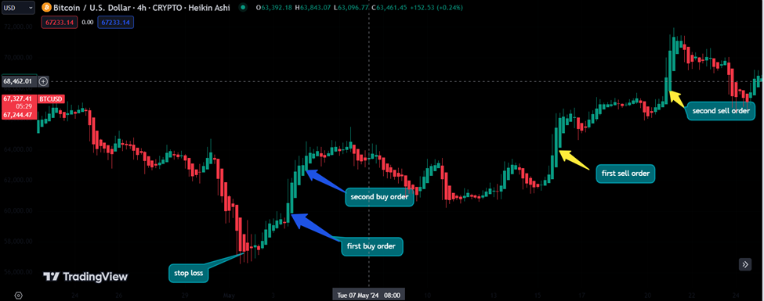 - This step is done automatically without manual input from me as a user.

Example Workflow **in future trading**

I will have the liberty to choose the following variable:

1. Coin any coin within the exchanges (MEXC, Binance, kucoin)
2. pair (USDT, BTC, ETH, TRY)
3. I can choose any time frame I want (5min,1hour,4hours…)
4. I can choose one or two buy/sell order
5. buy order 1 (I can buy 50%)
6. buy order 2 (I buy with the other 50%)
7. sell order 1 (I will take profit 50%)
8. sell order 2 (I will take the second)
9. stop loss
10. leverage (as future trading only)

1. Setup Buy Order:

- I will set a buy limit order at a specified price (50,200 USDT for Bitcoin) as LONG and the leverage will be 3X and my stop loss will be 2% below the entry price which is 52,000USDT

- The bot then will monitor the price, if it gets below 2% for example it will sell it to prevent me from further lost

2. Setup Sell Order:

- Upon execution of the buy order, the bot automatically sets a sell limit order at the target price (50,300 USDT for Bitcoin).

- This step is done automatically without manual input from me as a user.

Application to Trading Types

1. Spot Trading:

- Directly buy and sell the any cryptocurrency I want.

2. Futures Trading:

- Buy and sell contracts that derive their value from the underlying cryptocurrency.

- The bot manages contract positions, ensuring timely entry and exit based on pre-set conditions.